**SMART MEDICINE SCHEDULER**

# ABSTRACT

Medication adherence is a critical factor in achieving positive health outcomes, particularly for elderly individuals and patients with chronic illnesses who rely on timely and accurate medication intake. Non-adherence can lead to worsening health conditions, increased hospitalizations, and higher healthcare costs. Traditional reminder methods—such as manual schedules and mobile alarms—often fall short, as they depend heavily on memory, technical skills, or constant supervision. Addressing this challenge, the Smart Medicine Scheduler project offers an affordable, user-friendly solution by integrating an Arduino Nano microcontroller with a DS3231 Real-Time Clock (RTC) module, LCD display, buzzer, LEDs, and push buttons. This standalone system operates without the need for internet connectivity or smartphones, providing timely audio-visual reminders: a buzzer sounds, an LED lights up, and the LCD displays essential medication details at scheduled intervals. Patients can easily confirm medication intake by pressing a dedicated button, thereby encouraging consistent adherence. Designed for flexibility, the system allows users to set customizable schedules based on individual needs and features an intuitive interface suitable for elderly users and those unfamiliar with digital devices. Looking ahead, the system can be enhanced with IoT capabilities for remote caregiver monitoring, AI-driven dynamic scheduling based on patient behavior, and emergency alerts for missed doses. Additional planned features include multilingual support and voice prompts to further improve accessibility and inclusivity. In summary, the Smart Medicine Scheduler is a reliable, innovative, and inclusive tool designed to enhance medication adherence and promote better healthcare outcomes for vulnerable populations.

# TABLE OF CONTENTS

ABSTRACT

TABLE OF CONTENTS

LIST OF TABLE

LIST OF FIGURES

LIST OF ABBREVIATION

CHAPTER 1 1

1.1 Overview 1

1.2 Applications 2

CHAPTER 2 LITERATURE REVIEW 4

2.1 Technical Background 4

2.2 Related Works 5

2.2.1 Inference from the Literature Review 6

CHAPTER 3 PROPOSED METHODOLOGY 7

3.1 Problem Statement 7

3.2 Objectives 7

3.3 Methodology 7

3.4 Advantages 8

3.4 Scope of the Project 10

3.5 Hardware 11

3.6.1 Arduino Nano 11

3.6.2 RTC Module (DS3231) 13

3.6.3 Light Emitting Diodes 15

3.6.4 16X2 LCD Display 16

3.6.5 Buzzer 18

3.6.6 Jumper wires 19

3.6.7 Push Buttons 20

3.6.8 Potentiometer 21

3.6 Block Diagram 22

3.7 Flow Chart 23

CHAPTER 4 26

RESULTS AND DISCUSSION 26

CHAPTER 5 29

CONCLUSION 29

REFERENCES 30

# LIST OF TABLE

**Table No. Page**

4.1 LED color reading for the medicine group 27

# LIST OF FIGURES

**Figure No. Page**

3.6.1 Ardiuno Nano 13

3.6.2 RTC Module (DS3231) 15

3.6.3 Light Emitting Diodes 16

3.6.4 16X2 LCD Display 17

3.6.5 Buzzer  18

3.6.6 Jumper wires  19

3.6.7 Push Buttons  20

3.6.8 Potentiometer 21

3.7 Block Diagram of Smart Medicine Remainder 23

3.8 Flow Chart of Smart Medicine Remainder 25

4.1 Working Hardware Model 28

# LIST OF ABBREVIATION

|  |  |
| --- | --- |
| **LED** | Light Emitting Diode |
| **RTC** | Real-Time Clock |
| **LCD** | Liquid Crystal library |
| **GSM** | Global System for Mobile Communication |
| **IDE** | Integrated Development Environment |
| **USB** | Universal Serial Bus |
| **GND** | Ground |
| **INC** | Increment |
| **EEPROM** | Electrically Erasable Programmable Read-Only Memory |
| **PWM** | Pulse Width Modulation |
| **TCXO** | Temperature-compensated crystal oscillator |

# CHAPTER 1

**INTRODUCTION**

In today’s rapidly advancing healthcare landscape, ensuring timely and consistent medication intake stands as one of the most critical pillars of effective patient care. Medication adherence, particularly among elderly individuals and those managing chronic illnesses, continues to pose a formidable challenge. Frequent lapses—such as missed doses or incorrect timing—can precipitate serious health complications, increase hospitalization rates, and drive up healthcare expenditures. Despite significant progress in mobile health applications and smart healthcare technologies, a substantial segment of the population, especially older adults, struggles to navigate complex digital platforms and interfaces. This reality underscores an urgent need for a simple, reliable, and cost-effective solution to facilitate medication management without overreliance on smartphones, applications, or continuous caregiver oversight.

The Smart Medicine Scheduler directly addresses this pressing issue through a standalone, hardware-based reminder system. Centered around an Arduino Nano microcontroller and equipped with a Real-Time Clock (RTC) module, the system delivers timely audio-visual alerts via buzzers, LEDs, and an intuitive LCD display.

Beyond merely improving medication adherence, the project aspires to alleviate caregiver burden, minimize medication errors, and enhance overall patient outcomes. Its low-cost, user-centric design makes it particularly well-suited for elderly users, rural communities, and individuals with limited access to advanced technological infrastructure.

## Overview

Despite the rapid proliferation of mobile health applications and the emergence of advanced smart pill dispensers, a substantial gap remains in addressing the practical and financial challenges associated with daily medication management. While many of these modern solutions offer impressive features—such as automated dispensing, app-based tracking, and real-time alerts—they are often financially out of reach for the average consumer, particularly in developing regions. Their technological complexity can also be intimidating for elderly individuals, people with limited digital literacy, or those with cognitive impairments, who may struggle with configuration, troubleshooting, or navigating app interfaces.

Moreover, these systems commonly depend on continuous access to smartphones, Wi-Fi, or mobile data networks, posing a serious limitation in rural and remote areas where such connectivity is unreliable or altogether unavailable. This digital divide excludes large segments of the population, particularly low-income households and aging individuals living alone, from reaping the benefits of these advancements. The outcome is a widespread unmet need for an accessible, low-maintenance solution that empowers users to independently manage their medication schedules without digital dependencies.

This situation highlights the urgent necessity for a cost-effective, durable, and user-friendly medication reminder system that transcends technological and socio-economic barriers. Such a solution must emphasize reliability, simplicity, and inclusiveness in its design—enabling patients to remain consistent with their medication regimens, reduce missed doses, and improve long-term health outcomes. In doing so, it has the potential to bridge the healthcare accessibility gap, enhance quality of life, and reduce the burden on caregivers and medical professionals alike.

## 1.2 Applications

1. **Elderly Care Centers**
   * Helps senior citizens manage complex medication schedules without relying on memory or caregivers, improving their independence.
2. **Home Healthcare Monitoring**
   * Assists patients recovering from surgeries or illnesses at home by ensuring they take prescribed medications on time without needing a nurse’s supervision.
3. **Support for Alzheimer’s and Dementia Patients**
   * Provides consistent audio-visual reminders for patients with memory loss, reducing the chances of missed or repeated doses.
4. **Chronic Disease Management**
   * Aids patients suffering from conditions like diabetes, hypertension, and heart diseases who require strict daily medication routines.
5. **Pediatric Medication Reminders**
   * Ensures that children receive the right dosage at the right time, minimizing the risk of overdose or missed doses in pediatric care.
6. **Hospital and Clinic Bedside Installations**
   * Can be installed at patient bedsides to automate reminders for nurses, reducing human error and manual tracking in busy hospital environments.
7. **Post-Surgery Recovery Management**
   * Supports strict antibiotic, painkiller, and supplement intake schedules for faster healing during post-surgical recovery phases.
8. **Rural and Remote Healthcare Outreach**

* Provides a simple, offline solution for patients in underserved areas, reducing dependence on healthcare professionals and promoting self-management of medication routines.

1. **Rehabilitation and Physiotherapy Centers**

* Helps patients in rehabilitation maintain timely medication schedules, supporting holistic recovery plans and improving compliance in outpatient settings.

1. **Palliative and Hospice Care**

* Offers gentle, non-digital reminders to ensure timely pain management and consistent care for patients in palliative or hospice settings, promoting dignity and comfort.

1. **Medication Adherence in Mental Health Treatment**

* Assists patients with mental health conditions in maintaining medication adherence, preventing relapses due to missed doses and supporting consistent treatment.

1. **Support for Visually or Hearing Impaired Individuals**

* Combines auditory buzzers and visual LEDs to ensure medication reminders are accessible to those with sensory impairments, with adjustable settings for personalized needs.

1. **Geriatric Companion Robots or Assistive Devices**

* Can be integrated into companion robots or smart home systems for the elderly, adding medication tracking functionality while maintaining independent operation.

1. **Educational Demonstration Tool for Health Awareness**

* Serves as an interactive tool in health campaigns or nursing programs to educate on medication adherence and demonstrate how technology can enhance self-care.

# CHAPTER 2 LITERATURE REVIEW

## Technical Background

Efficient medication management plays a pivotal role in maintaining health, particularly for elderly individuals and patients with chronic conditions. Traditional solutions, such as manual pill organizers and smartphone-based applications, often face limitations regarding usability, affordability, and accessibility. To overcome these challenges, our project introduces the Smart Medicine Scheduler, designed using cost-effective and widely available electronic components.

At the heart of the system is the Arduino Nano, a compact, economical microcontroller ideal for embedded system applications. Acting as the central controller, it orchestrates the various modules according to a predefined medication schedule. To ensure precise timing, a Real-Time Clock (RTC) module is integrated, maintaining accurate timekeeping even during power interruptions or system restarts.

User interaction is facilitated through a 16x2 LCD display, which presents real-time data such as the current time, upcoming medication alerts, and pill details. Visual notifications are provided via three color-coded LEDs, each corresponding to a specific pill compartment, enabling users to easily identify which medication to take. Complementing the visual alerts, a buzzer delivers audible reminders to ensure timely intake.

The system is programmed with a straightforward, intuitive interface that allows users or caregivers to effortlessly set and update medication schedules. By eliminating the reliance on smartphones, mobile applications, or internet connectivity, the design specifically caters to elderly users and individuals in remote or resource-limited areas.

Furthermore, the Smart Medicine Scheduler offers a highly adaptable and modular framework, allowing easy future enhancements such as integrating additional LEDs for more medications or incorporating sensors for pill verification. In essence, it provides a cost-efficient, dependable, and user-friendly solution for daily medication adherence, with the flexibility to evolve alongside user needs.

## 2.2 Related Works

Over the past decade, several solutions have been developed to address the challenges of medication adherence through technological innovations. In 2012, Jeffrey K. Aronson highlighted in his study the significant consequences of poor medication compliance, emphasizing the urgent need for assistive devices. This sparked an increase in research around electronic medication reminders.

In 2015, Anusha et al. proposed an "Automatic Pill Reminder and Dispenser" using Arduino Uno, LCD, and GSM modules. Their system could send SMS alerts to patients and caregivers. However, the reliance on GSM technology made it relatively expensive and dependent on network availability.

In 2017, Patel and Doshi developed a "Smart Pill Box" using microcontrollers and real-time clock modules. Their design featured alarms and visual indicators, which greatly improved user-friendliness, particularly for elderly patients. Nevertheless, the system's cost and complexity limited its accessibility.

In 2019, Chakraborty et al. introduced a "Low-Cost Smart Medicine Reminder" based on Arduino and RTC modules. Their project was aimed at rural areas where smartphone penetration was low. It used buzzers and LED indicators to notify users, a design philosophy similar to our approach but with limited customization options.

Recently, in 2021, Shaik et al. developed a medication adherence system that combined IoT features with mobile applications. While it provided real-time monitoring and data storage, the dependency on smartphones and internet connectivity restricted its use among the elderly population.

Building upon these previous works, our project focuses on an **offline, Arduino Nano-based smart medicine scheduler** using an LCD display, RTC module, buzzer, and three LEDs for clear pillbox indication. Unlike earlier systems, it emphasizes simplicity, low cost, modularity, and independence from smartphones and internet connectivity, ensuring greater usability and accessibility for the elderly and rural populations.

### 2.2.1 Inference from the Literature Review

Based on the literature survey, several key insights and inferences can be drawn to guide the work on “Smart Medicine Scheduler using Arduino-Nano”.

* **Existing Solutions**:
  + Early smart pill dispensers (2013 onward) used real-time tracking and network connectivity but were expensive and less accessible.
  + Arduino-based simple reminders (around 2016) demonstrated low-cost possibilities but often lacked intuitive multi-pill handling.
* **IoT and Mobile App Integration**:
  + Projects from 2018–2019 integrated IoT and mobile applications for remote monitoring.
  + These systems required stable internet connections and smartphones, making them unsuitable for elderly or rural users.
* **Challenges Identified**:
  + Dependence on smartphones and internet connectivity remains a major barrier for a large portion of the target audience.
  + Systems with too many features often become complex and intimidating for non-technical users.
  + Affordability and ease of use are critical factors often overlooked in advanced systems.
* **Critical Requirements for an Effective System**:
  + Must be standalone (no internet or smartphone dependency).
  + Should offer simple, clear audio-visual notifications.
  + Needs to be low-cost, durable, and easy to maintain.
  + Must be modular and flexible for different user needs (e.g., multiple medicines).
* **Our Project’s Approach**:
  + Utilizes Arduino Nano, RTC module, LCD display, buzzer, and LEDs — all affordable and widely available components.
  + Focuses on maximum accessibility for elderly users and people in rural or underprivileged areas.
  + Ensures reliable daily medication adherence through a simple and effective design.

# CHAPTER 3 PROPOSED METHODOLOGY

## 3.1 Problem Statement

Despite the wide availability of mobile apps and smart pill dispensers, there remains a critical gap in delivering a simple, affordable, and truly effective solution for daily medication management. Most existing options are either prohibitively expensive, overly complicated, or unsuitable for elderly users, often requiring technical skills, smartphone access, or stable internet connectivity. These limitations contribute to poor medication adherence, posing serious health risks. Consequently, there is an urgent need for a low-cost, reliable, and highly user-friendly medication reminder system that operates independently of smartphones and the internet, ensuring accessibility for seniors, rural populations, and underserved communities.

## Objectives

Our primary goal is to develop a Smart Medicine Scheduler that offers a simple, cost-effective, and dependable solution for daily medication management. With a focus on independence, the system is designed to function autonomously, without reliance on smartphones or internet connectivity. This design enhances accessibility, particularly for elderly users and individuals residing in rural or underserved areas, where access to advanced healthcare tools may be limited. By eliminating the need for smartphones or continuous internet, the system ensures greater usability in environments where these technologies may be impractical or unavailable.

1. **Development of a Standalone Medication Reminder System**

The core objective is to create a self-sufficient device capable of delivering timely medication reminders. The system will leverage an Arduino Nano, paired with a Real-Time Clock (RTC) module, ensuring accurate and reliable timekeeping even during power interruptions. An LCD display will visually present the time and medication reminders, and a buzzer will provide auditory notifications. Additionally, LED indicators will be employed, each corresponding to a specific pill compartment, guiding users toward the correct medication. The system will run on a simple, reliable circuit, requiring no external connections or maintenance, making it suitable for users of all technical skill levels. This design ensures users can adhere to their medication schedules consistently and accurately without external intervention or technical complications.

1. **Emphasis on Affordability, Simplicity, and User-Centric Design**

At the heart of this project is a commitment to creating a low-cost solution using readily available, cost-effective components that can be easily sourced in diverse regions. The user interface will be deliberately intuitive and straightforward, featuring LED indicators that visually highlight the specific pill compartment associated with each reminder. The LCD display will show critical information such as the current time and scheduled medication, offering a clear and simple interface for users to follow. The integration of a buzzer will ensure that individuals with visual impairments or those who may have difficulty reading the LCD can still receive timely medication alerts audibly. By focusing on simplicity, we aim to ensure the system is accessible for individuals with varying degrees of digital literacy and technical expertise, making it inclusive and adaptable to a wide range of users, from seniors to individuals recovering from surgery or managing chronic conditions.

The design philosophy of this project centers around reliability and ease of use, with a focus on reducing technical barriers and making medication adherence as straightforward as possible. The system is designed to empower individuals to manage their health without relying on external devices or complex setups, fostering greater independence and improving overall health outcomes.

.

## Methodology

The development of the Smart Medicine Scheduler adheres to a structured and methodical approach aimed at ensuring simplicity, reliability, and user-centric design. This project prioritizes ease of use, especially for elderly users or individuals with limited technical proficiency, by eliminating dependence on external devices or connectivity.

At the outset, hardware components are meticulously chosen based on factors such as local availability, cost-effectiveness, energy efficiency, and seamless integration. The Arduino Nano is selected as the primary control unit owing to its compact size, low power consumption, and adequate processing capabilities required for time-based operations. A Real-Time Clock (RTC) module (DS1307) is integrated into the system to maintain accurate timekeeping, even during power outages, through its onboard battery backup. This feature is critical for ensuring that medication reminders are triggered precisely on schedule without disruption.

For visual output, a 16x2 LCD display is incorporated to provide real-time feedback, displaying both the current time and upcoming medication alerts. Its clear and readable interface enhances the accessibility of the system, especially for visually impaired users. To simplify medication identification, three LEDs are strategically assigned to three distinct pill compartments. These LEDs illuminate independently based on the scheduled medicine, guiding users clearly on which pill to take.

To further reinforce reminders, a buzzer is added to deliver an audible alert, ensuring notifications are noticed even when the user is not actively monitoring the display. The buzzer's sound parameters are calibrated to be attention-grabbing yet non-intrusive.

Programming is conducted using the Arduino IDE, where the system logic is designed to perform continuous real-time comparisons between the RTC-provided current time and a predefined medication schedule stored in the microcontroller’s memory. When a match is detected, the corresponding LED is activated, the buzzer is triggered, and relevant medication information is displayed on the LCD screen, guiding the user through the process.

A rigorous testing phase follows, encompassing multi-stage validation of the system's core functionalities. This includes verifying the accuracy of the RTC, responsiveness and brightness of LEDs, clarity and stability of LCD output, and the volume and duration of the buzzer’s alert. Iterative refinements are implemented based on observed performance, ensuring optimal visibility, audibility, and ease of operation.

In conclusion, this structured design methodology culminates in the realization of a cost-efficient, standalone, and highly accessible medicine reminder system. It effectively promotes daily medication adherence, particularly for those without access to smartphones or internet connectivity, making it a valuable solution for remote or underserved communities.

## 3.4 Advantages

The development of the Smart Medicine Scheduler, as described, offers several advantages that contribute to its effectiveness, user-friendliness, and reliability:

1. **Simplicity**:

The design prioritizes a straightforward user interface with clear notifications (LCD display and LEDs), making it easy for users to operate and understand without technical expertise.

1. **Compact and Affordable**:

The use of an Arduino Nano ensures a small, cost-effective solution that is easy to assemble and integrate with other components, making it accessible for a wide range of users.

1. **Reliability**:

The inclusion of an RTC module ensures accurate timekeeping even during power outages, guaranteeing that medication reminders occur on time, enhancing the system's reliability.

1. **Independent of Internet/Smartphone**:

The system does not require an internet connection or smartphone, making it ideal for users who may not have access to mobile devices or a stable internet connection.

1. **Visual and Auditory Alerts**:

The combination of LEDs and a buzzer ensures that users are alerted both visually and audibly, providing a failsafe for users who may not notice one type of alert (e.g., if they are in another room or distracted).

1. **Customizable**:

The system can be programmed to accommodate multiple medications with different schedules, giving flexibility for users with varied needs.

1. **Increased Medication Adherence**:

By automating the reminder system, the scheduler helps users follow their prescribed medication regimen more reliably, potentially improving health outcomes.

1. **User-Centered Design**:

The system is designed to be intuitive with easy-to-read notifications and minimal input required, making it suitable for individuals of all ages, especially the elderly or those with memory challenges.

1. **Energy Efficiency**:

The use of low-power components (like Arduino Nano) ensures that the system is energy-efficient, capable of running for extended periods on minimal power, reducing the need for frequent charging or battery replacements.

1. **Easy Maintenance**:

The modular nature of the system (separate components for timekeeping, display, LED alerts, and buzzer) allows for easy replacement and maintenance, ensuring long-term usability.

1. **Comprehensive Testing and Iterative Refinement**:

The focus on thorough testing and adjustments ensures that the system is optimized for performance, making it more effective at delivering timely alerts and being responsive to user needs.

1. **Stand-Alone Functionality**:

The solution’s ability to function without dependence on smartphones or complex systems makes it highly practical for users who prefer a standalone, low-tech solution to medication management.

1. **Portability**  
    The smart medicine scheduler is compact and easy to carry, making it convenient for patients who travel or move frequently. With mobile app integration and battery-powered operation, users can receive reminders anywhere, anytime. This portability ensures that medication adherence is maintained even outside the home environment.
2. **Analytics and Reports**

The system records medicine intake data and generates useful reports showing daily and monthly adherence. These analytics help patients and doctors monitor treatment effectiveness and adjust schedules as needed. Easy-to-read charts and summaries also encourage users to stay consistent with their medications.

1. **Reduced Hospitalization**

By ensuring regular medicine intake, the scheduler helps prevent complications that can lead to hospitalization. Early alerts for missed doses allow caregivers or doctors to intervene before a condition worsens. This proactive approach reduces emergency visits and supports better long-term health outcomes.

## Scope of the Project

The primary scope of this project is to design and develop a Smart Medicine Scheduler, a compact and user-friendly embedded system that assists individuals in adhering to their prescribed medication routines. The project utilizes an Arduino Nano microcontroller as the core processing unit, integrated with a 16x2 LCD display, a DS3231 Real-Time Clock (RTC) module, a buzzer, and LED indicators. Together, these components create an intelligent reminder system that provides both audio and visual cues to notify users when it is time to take their medication.

This system is particularly targeted at elderly individuals, chronically ill patients, and people with memory impairments, who may struggle to maintain consistent medication schedules. In many such cases, missed or incorrect doses can lead to serious health complications, reduced treatment effectiveness, or even hospitalization. This project addresses these challenges by offering a reliable, automated reminder mechanism that operates throughout the day—ensuring timely intake of medication.

The RTC module plays a crucial role in maintaining precise and uninterrupted time tracking. Even during power outages, its battery backup ensures that scheduled alarms are not missed, and there is no need for manual resetting. Based on the pre-programmed schedule, the RTC triggers events at designated times—typically for morning, afternoon, and evening doses. Upon reaching a scheduled time, the system activates the buzzer to produce an audible alert and illuminates the corresponding LED, indicating which compartment or time block the medication belongs to.

The LCD display complements this by showing relevant information such as the current time, upcoming reminder, and guidance messages (e.g., “Take Morning Medicine”). This makes the system intuitive and accessible, even for users with limited technical knowledge.

The key objectives addressed by this project include:

* Enhancing medication adherence by reminding users at the exact scheduled times.
* Minimizing medication errors by clearly distinguishing between different dose times using separate LEDs.
* Promoting patient independence, reducing reliance on caregivers for basic health management tasks.
* Providing a low-cost solution that is affordable and easy to deploy in diverse environments.

The system’s design emphasizes simplicity, affordability, and reliability, making it ideal for deployment in a variety of settings including private homes, hospitals, rehabilitation centers, and elderly care facilities. Its modular structure allows for potential future upgrades, such as increasing the number of daily reminders, integrating wireless communication modules for remote monitoring, or even connecting to mobile apps for enhanced user control.

## Hardware

### 3.6.1 Arduino Nano

The Arduino Nano is a small yet powerful microcontroller board designed around the ATmega328P processor, offering a perfect balance between compact size and strong performance. Measuring just 1.8 cm by 4.5 cm, the Nano provides almost the same capabilities as the larger Arduino Uno but in a much smaller, breadboard-friendly format.

The Arduino Nano comes equipped with 14 digital input/output pins, out of which 6 can be used as PWM outputs, along with 8 analog input pins that allow for precise sensor data collection. It features a mini USB port for easy programming and power supply, a dedicated reset button, and an ICSP header for in-circuit programming. Operating at 5V with a 16 MHz clock speed, the Nano delivers reliable processing power for a wide range of embedded applications, including automation, robotics, and IoT systems.

One of the key advantages of the Arduino Nano is its affordability and wide availability, making it a favorite among hobbyists, students, and professionals. Programming the board is straightforward using the Arduino IDE, which offers extensive libraries, sample codes, and community support, thereby reducing development time and effort. The board can be powered either through the USB connection or via an external 6-12V unregulated power source, providing flexibility in various project environments.

Thanks to its compact design and ability to plug directly into standard breadboards, the Nano simplifies prototyping and circuit testing. Its portability and easy integration with sensors, actuators, and wireless modules make it an ideal choice for projects like smart medicine schedulers, where size, reliability, and connectivity are critical. In summary, the Arduino Nano is a dependable, versatile platform for creating compact and efficient embedded systems.

The onboard voltage regulator helps maintain stable performance even when powered by varying external sources. Due to its lightweight structure, the Nano is also a preferred choice for wearable technology and portable health monitoring systems. Overall, its flexibility, combined with a rich ecosystem of compatible components, makes the Arduino Nano a cornerstone in modern electronics prototyping.

**Specifications**

* **Microcontroller**: ATmega328P
* **Operating Voltage**: 5V
* **Input Voltage (recommended)**: 7V to 12V
* **Input Voltage (limits)**: 6V to 20V
* **Digital I/O Pins**: 14 (of which 6 provide PWM output)
* **Analog Input Pins**: 8
* **DC Current per I/O Pin**: 40 mA (maximum)
* **Flash Memory**: 32 KB (of which 2 KB used by bootloader)
* **SRAM**: 2 KB
* **EEPROM**: 1 KB
* **Clock Speed**: 16 MHz
* **USB Connection**: Mini USB
* **Dimensions**: 18 mm × 45 mm
* **Weight**: Approximately 7 grams
* **Communication Protocols**: UART, SPI, I2C
* **Programming**: Supported through Arduino IDE
* **Reset Button**: Available
* **Power Supply Options**: USB connection or external power via VIN pin

**Advantages in Embedded Applications:**

One of the Nano’s standout strengths is its balance between functionality and form factor. Its lightweight, thin profile allows it to be directly inserted into standard breadboards, making prototyping simple and efficient. The wide array of I/O pins makes it capable of interfacing with multiple peripherals simultaneously—such as sensors, actuators, displays, and communication modules—without the need for excessive wiring or expansion boards.

In the Smart Medicine Scheduler, the Nano’s resources are effectively utilized:

* Digital Pins control the LEDs and buzzer for timely alerts.
* Analog Pins can be extended to accommodate sensor inputs or additional user controls.
* The board handles real-time display updates, time comparison algorithms, and user input detection, all with minimal power consumption and high reliability.

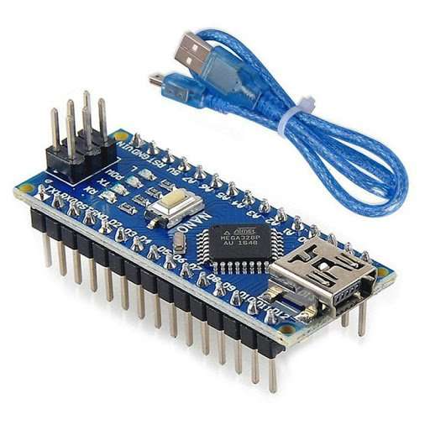

**Figure 3.6.1: Arduino Nano**

### 3.6.2 RTC Module (DS3231)

The RTC (Real-Time Clock) module is a crucial timekeeping component in electronic systems, designed to maintain accurate time even when the main power source is disconnected. It typically records seconds, minutes, hours, days, dates, months, and years. RTC modules are vital for applications such as data logging, alarms, calendars, and embedded systems that require continuous, precise time tracking.

Modules like the DS1307 and DS3231 usually run on a small coin cell battery, allowing them to function during power interruptions. The DS3231, in particular, features a temperature-compensated crystal oscillator to minimize time drift caused by temperature variations, ensuring high accuracy.

Connecting an RTC module to a microcontroller (like Arduino or Raspberry Pi) enables the system to perform scheduled operations, timestamp events, or simply display the current time and date. Setting up an RTC involves initializing the correct time and regularly reading or updating the time during operation.

In summary, RTC modules are indispensable for providing reliable and accurate timekeeping across a wide range of electronic and embedded system projects.

**Specifications**

* **Clock Accuracy**: ±2 ppm (parts per million) from 0°C to +40°C, ±3.5 ppm from -40°C to +85°C
* **Timekeeping**: Tracks seconds, minutes, hours, day, date, month, and year
* **Leap Year Handling**: Automatic adjustment until the year 2100
* **Voltage Range**: 2.3V to 5.5V
* **Communication Interface**: I2C (Serial Data Line – SDA, Serial Clock Line – SCL)
* **I2C Address**: 0x68 (default)
* **Temperature Sensor**: Built-in; range from -40°C to +85°C with ±3°C accuracy
* **Alarm Functions**: Two programmable alarms
* **Square-Wave Output**: Programmable output frequencies (1Hz, 1.024kHz, 4.096kHz, 8.192kHz)
* **Battery Backup**: Supports CR2032 coin cell (typical) for continuous operation during power loss
* **Current Consumption**:
  + Active mode: ~200µA
  + Battery mode: ~3µA
* **Oscillator**: Temperature-compensated crystal oscillator (TCXO)
* **Dimensions** (Module size typical): Approximately 38mm x 22mm

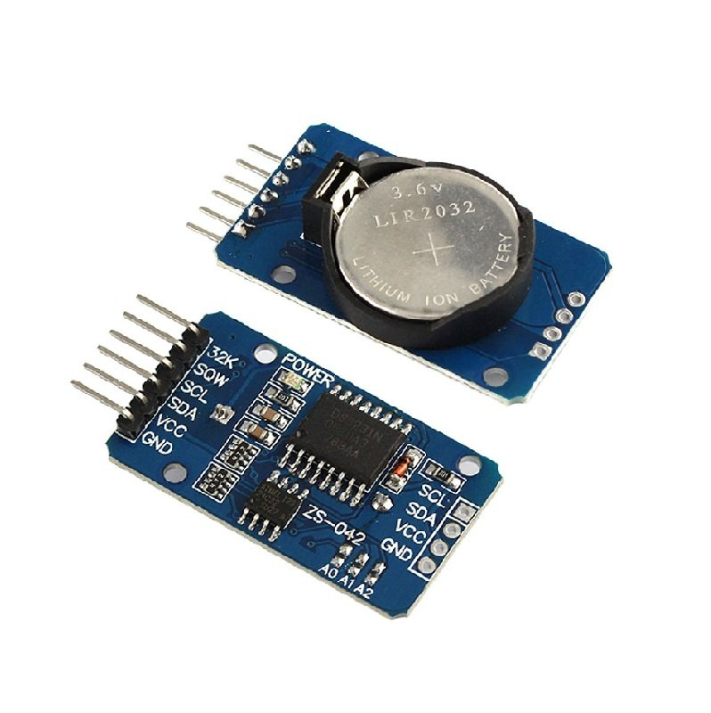

**Figure 3.6.2: RTC Module (DS3231)**

### 3.6.3 Light Emitting Diodes

LEDs (Light Emitting Diodes) are semiconductor devices that produce light when an electric current flows through them. They are highly energy-efficient, generating minimal heat and consuming significantly less power than traditional incandescent bulbs. Available in colors like red, green, blue, and white, LEDs are commonly used in indicators, displays, lighting, and decorative applications.

Their operation relies on electroluminescence—light is emitted when electrons recombine with holes in the semiconductor material. LEDs are polarized, meaning the longer lead (anode) connects to the positive side of a circuit, and the shorter lead (cathode) connects to ground.

In electronic projects, LEDs serve as indicators for system status or provide visual feedback, typically paired with a current-limiting resistor to prevent damage from excessive current. Advanced types like RGB LEDs can create a wide spectrum of colors by varying the intensity of red, green, and blue light.

Overall, LEDs are vital components in modern electronics, prized for their long lifespan, reliability, and outstanding energy efficiency.

**Specifications**

* **Type**: Indicator LED (standard 5mm or 3mm size)
* **Forward Voltage**: Typically 1.8V to 3.3V  
  (Red: ~1.8V–2.2V, Green/Blue/White: ~2.8V–3.3V)
* **Forward Current**: 10mA to 20mA (standard operating current)
* **Maximum Forward Current**: 30mA (above this can damage the LED)
* **Reverse Voltage**: 5V (maximum; LEDs are sensitive to reverse voltage)
* **Luminous Intensity**: Varies from 100 mcd to 5000 mcd (depends on color and type)
* **Viewing Angle**: Typically 20° to 60°
* **Operating Temperature Range**: -40°C to +85°C
* **Polarity**:
  + Long lead → Anode (+)
  + Short lead → Cathode (–)
* **Color Options**: Red, Green, Blue, Yellow, White, RGB (multi-color)
* **Power Dissipation**: 60mW to 100mW (approximate, depends on the LED)

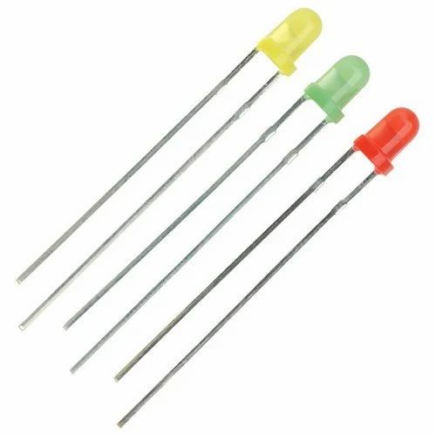

**Figure 3.6.3: Light Emitting Diode**

### 3.6.4 16X2 LCD Display

An LCD (Liquid Crystal Display) is an electronic display commonly used in a wide range of applications. The 16x2 LCD module, which can display 16 characters per line on 2 lines, is one of the most widely used types due to its simplicity and effectiveness. It is often preferred over seven-segment and multi-segment LED displays for displaying text and data in projects.

**1. Hardware Required**

* Arduino Board
* 16x2 LCD Module (compatible with Hitachi HD44780 driver)
* 10kΩ Potentiometer
* 220Ω Resistor

**2. Wiring the LCD Screen**

* Solder a pin header to the LCD’s 14 (or 16) pin connector.
* Connect the pins as follows:
  + **RS** → Digital Pin 12
  + **Enable (E)** → Digital Pin 11
  + **D4** → Digital Pin 5
  + **D5** → Digital Pin 4
  + **D6** → Digital Pin 3
  + **D7** → Digital Pin 2
  + **R/W** → GND
  + **VSS** → GND

**3. Liquid Crystal Library**

* The **Liquid Crystal library** simplifies working with LCD modules compatible with the HD44780 driver.
* LCDs can be operated in:
  + **4-bit mode** (uses 7 Arduino I/O pins)
  + **8-bit mode** (uses 11 Arduino I/O pins)
* 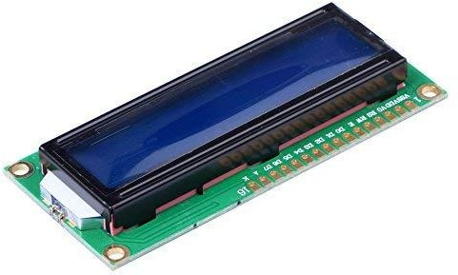For basic text display, **4-bit mode** is typically sufficient.

**Figure 3.6.4: LCD Display 16x2**

### 3.6.5 Buzzer

A buzzer is a basic audio output device widely used in electronic circuits to generate sound signals. Buzzers come in types such as mechanical, electromechanical, and piezoelectric, with piezo buzzers being the most common in modern electronics due to their small size, low power consumption, and easy interfacing with microcontrollers like Arduino.

Buzzers work by converting electrical energy into sound. When voltage is applied, they produce a tone, beep, or alarm. The sound can be continuous or pulsed based on how they are driven. Some buzzers include an internal oscillator and operate directly with a DC supply, while others require an external signal to generate sound.

**Specifications**

* **Type**: Piezoelectric (commonly used) or Electromechanical
* **Operating Voltage:** Typically 3V to 12V (depending on model)
* **Current Consumption:** Very low, around 10mA to 30mA
* **Sound Output:** 85 dB to 100 dB at 10 cm distance
* **Frequency Range:** Around 2 kHz to 4 kHz (typical for piezo buzzers)
* **Operating Temperature Range:** -20°C to +70°C
* **Size:** Small and compact (common diameters: 10mm, 12mm, 20mm)
* **Mounting Type:** Through-hole or surface mount
* **Control:**
  + Self-driven buzzers require only DC voltage.
  + Externally driven buzzers need a PWM (Pulse Width Modulation) or AC signal.
* **Polarity:** Usually polarized (+ and - terminals)
* **Durability:** Long operational life (up to 10,000+ hours)

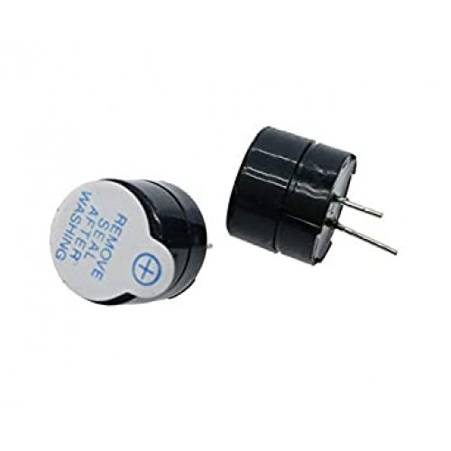

**Figure 3.6.5: Buzzer**

### 3.6.6 Jumper wires

Jumper wires are essential components widely used for creating quick and flexible connections between electronic parts on a breadboard or other prototyping platforms. Available in male-to-male, male-to-female, and female-to-female types, they enable easy linking of microcontrollers, sensors, modules, and power supplies without the need for soldering. Their reusable nature makes them ideal for experimenting and modifying circuits during development. By simplifying the circuit-building process, jumper wires help speed up prototyping and reduce errors caused by loose or faulty connections.

**Types of Jumper Wires:**

1. **Male to Male Jumper Wires**:
   * Have male connectors (pins) on both ends.
   * Suitable for plugging into standard 0.1-inch (2.54 mm) female sockets or breadboards.
   * **Typical Length**: Around 20 cm (8 inches).
2. **Female to Female Jumper Wires**:
   * Have female connectors on both ends.
   * Ideal for connecting components or modules that have male header pins.
   * **Typical Length**: Around 20 cm.
3. **Male to Female Jumper Wires**:
   * Feature a male connector on one end and a female connector on the other.
   * Useful for connecting male headers to female sockets or vice versa.
   * **Typical Length**: Around 20 cm.

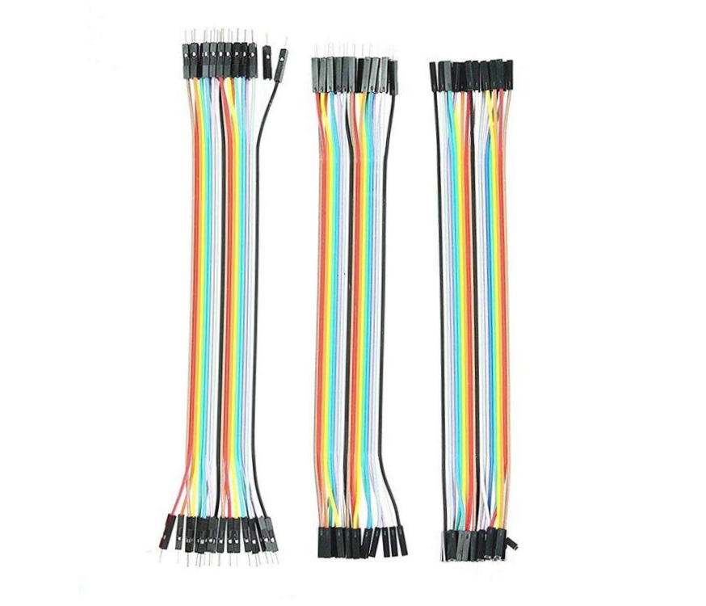

**Figure 3.6.6: Jumper wires**

### 3.6.7 Push Buttons

A push button is a crucial user input device used to interact with the system by sending a control signal when pressed. In this project, push buttons serve multiple functions:

* **Set Button**:
  + Initiates the time-setting mode.
  + Allows the user to begin setting alarms on the LCD screen.
* **Increment (INC) Button**:
  + Used to adjust the hour or minute values during time setting.
* **Next Button**:
  + Used to switch between hour and minute fields while setting the alarm times.
* **Acknowledge Button**:
  + Pressed by the user after the alarm triggers.
  + Stops the buzzer and returns the system to normal clock display mode.

**How Push Buttons Work in the Project:**

* When a button is pressed, it momentarily completes a circuit, sending a digital HIGH or LOW signal to the Arduino.
* Based on which button is pressed, the system responds by updating time values, saving alarm settings, or stopping the buzzer.
* Proper debouncing is handled in the code to ensure reliable button presses.

**Key Benefits:**

* Simple and reliable user interaction.
* Essential for manual control over setting and acknowledging alarms.
* Easy to interface with microcontrollers through digital input pins.

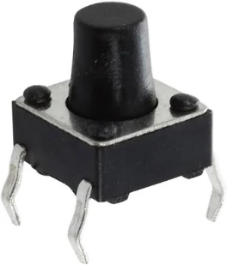

**Figure 3.6.7: Push Button**

### 3.6.8 Potentiometer

A potentiometer (pot) is a three-terminal variable resistor widely used to control voltage, adjust signal levels, and fine-tune electronic circuits. It functions by varying the resistance as its knob or slider is moved. A 10k potentiometer offers a total resistance of 10,000 ohms, making it ideal for tasks like brightness control, volume adjustment, and sensor calibration in various electronic applications.

**Key Features:**

* **Adjustable Resistance:** You can vary the resistance manually by rotating or sliding the potentiometer knob.
* **Three Terminals:**
  + **Terminal 1:** Connected to one end of the resistive track.
  + **Terminal 2 (Wiper):** Moves along the resistive track and picks the variable voltage.
  + **Terminal 3:** Connected to the other end of the resistive track.
* **Typical Use:** Acts as a voltage divider or variable resistor in circuits.

**Specifications:**

* **Resistance:** 10kΩ (fixed total resistance)
* **Type:** Rotary or linear (depending on physical design)
* **Material:** Carbon composition or cermet
* **Operating Voltage:** Typically up to 50V or more
* 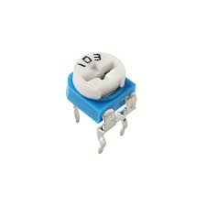**Power Rating:** Commonly 0.1W to 0.5W

**Figure 3.6.8: 10k pot**

## Block Diagram

The block diagram represents the working of the Smart Medicine Scheduler in a sequential and systematic manner. The system starts with the Power Supply / System Startup Block, where the Arduino Nano and the Real Time Clock (RTC) module are initialized. Simultaneously, the LCD display is activated to show the current real-time clock and date, giving immediate feedback to the user that the system is running. Once initialized, the system moves to the Time Setting Block, where the user can manually set the desired medication times. By pressing the ‘Set’ button, the LCD prompts the user with "Set Time 1," allowing adjustments using the increment (INC) button to set the hour and minute fields. The 'Next' button facilitates moving between these fields, and the user saves each set time. This process can be repeated to set multiple medication times, such as Time 2 and Time 3. After setting the alarms, the system transitions to the EEPROM Storage Block, where all the alarm times are stored in the Arduino’s EEPROM memory. This storage ensures that even if the device loses power, the preset alarms are retained, thus increasing the reliability and robustness of the system.

Following this, the system enters the Time Comparison Block, where it continuously compares the current real-time clock (RTC) data with the saved alarm times in EEPROM. This is done in real-time without user intervention. When the current time matches any of the preset alarm times, the system triggers the Alarm Trigger Block. At this point, the LCD displays which medicine group (Group Medicine 1, 2, or 3) needs to be taken, and a buzzer starts sounding to alert the user effectively. The LEDs corresponding to each group may also light up for better visual identification. To stop the alarm, the user needs to interact with the User Acknowledgement Block by pressing an ‘Acknowledge’ button. Once pressed, the buzzer stops buzzing, and the LCD reverts to displaying the real-time clock. This acknowledgment ensures that the system confirms the user has seen the alert. Finally, the system moves to the Loop Back to Time Comparison Block, where it resumes monitoring the real-time clock for the next scheduled alarm, ensuring continuous operation and multiple daily alerts without needing frequent resets or user inputs.

Through this logical and structured flow, the system ensures high reliability, user-friendliness, and effective medication reminders, particularly aiding elderly users or patients who may have multiple medicines scheduled throughout the day.

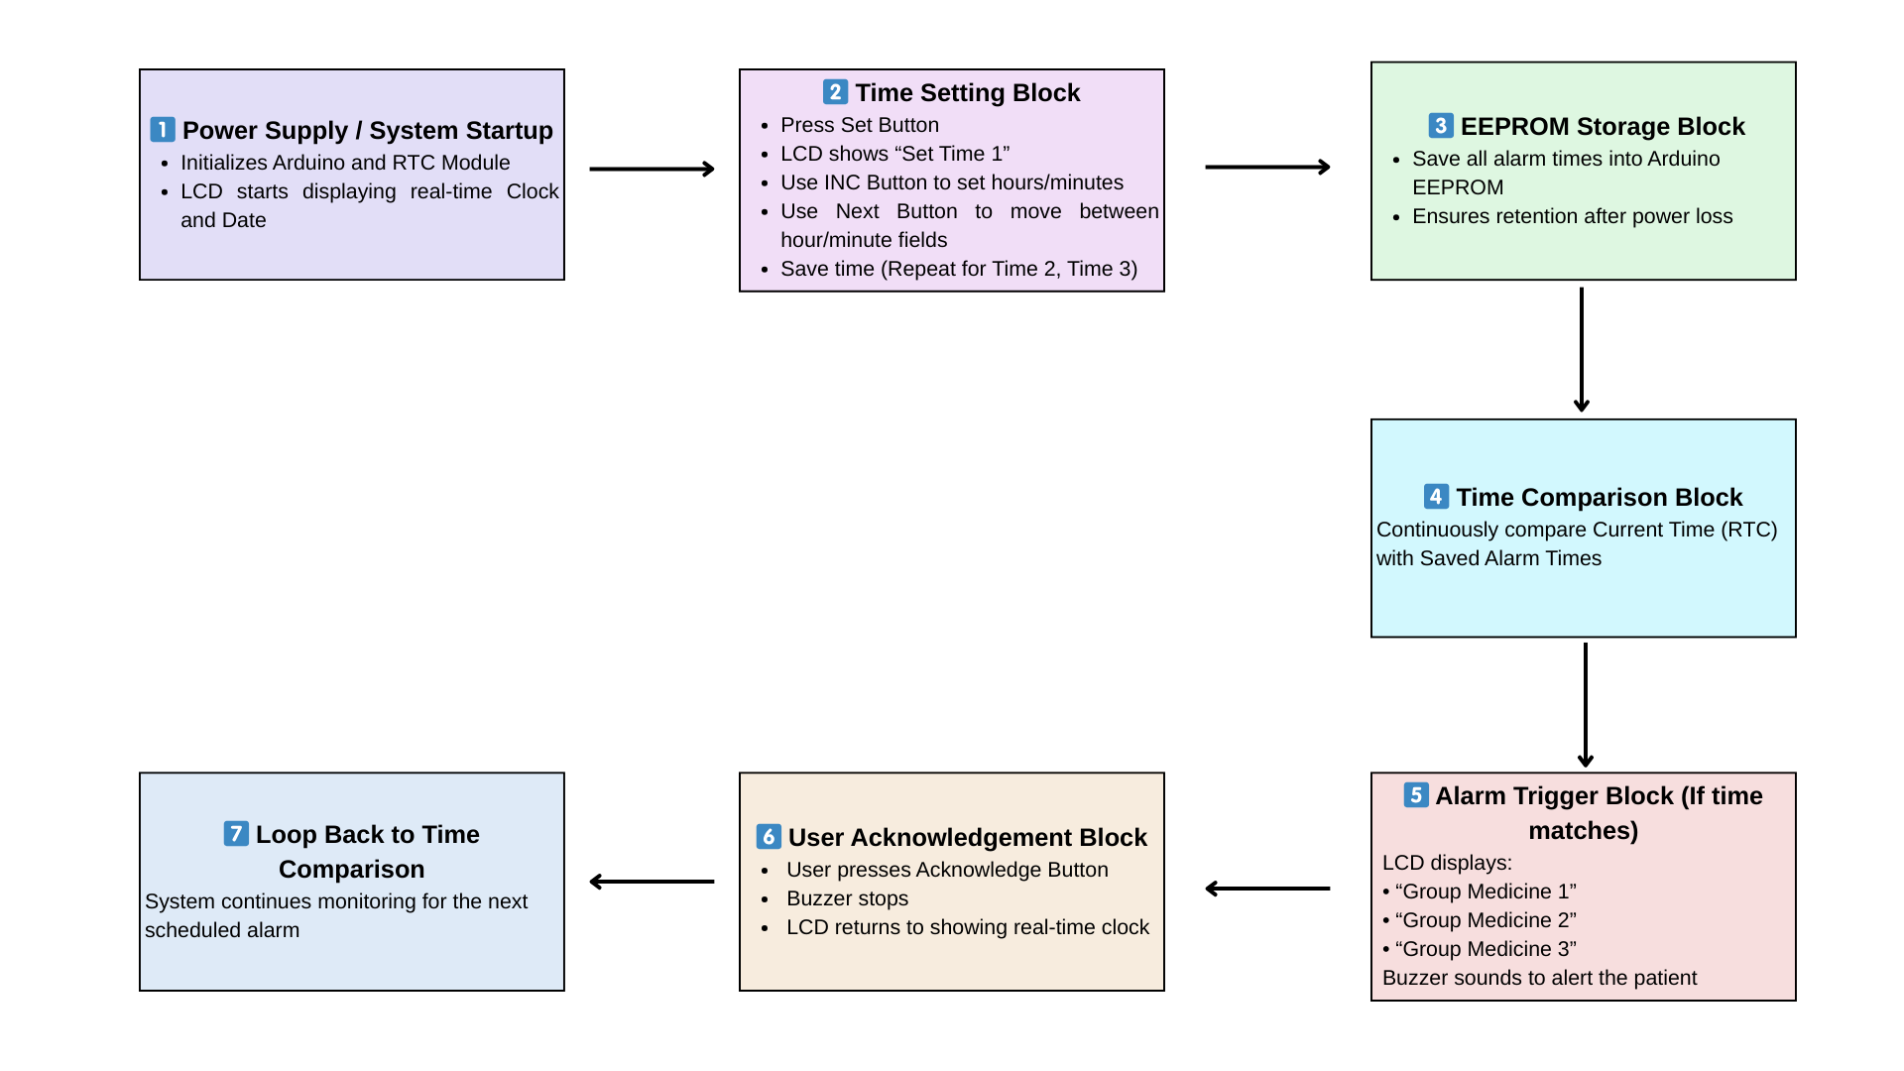

**Figure 3.7: Block Diagram of Smart Medicine Remainder**

## Flow Chart

**PROCEDURE FOR SMART MEDICINE REMINDER SYSTEM**

**1. Power ON and Initialization:**

When the device is powered ON, the system initializes all necessary components, primarily the Real-Time Clock (RTC) module. This ensures accurate tracking and display of the current date and time on the LCD screen.

**2. Displaying Time Setting Prompt:**

After initialization, the LCD displays a prompt such as "Enter Time 1", requesting the user to set the first medication reminder. The user is expected to configure three different medication times: Time 1, Time 2, and Time 3.

**3. Setting Medication Times:**

The user initiates the time-setting process by pressing the Set Button.

* The system allows adjustment of hours and minutes for each medication reminder.
* INC (Increment) and NEXT buttons are used to navigate and modify the time fields.
* Once a specific time is set, the user saves it, and the system automatically moves to the next time-setting prompt.

**4. Saving and Storing Alarm Times:**

Each configured alarm time is saved internally. To ensure data persistence even after a power cycle, the alarm times are stored in the device’s EEPROM (Electrically Erasable Programmable Read-Only Memory), providing non-volatile storage.

**5. Continuous Time Monitoring:**

Post time setting, the system continuously monitors the current time using the RTC module.

* It compares the current time with the saved alarm times through an uninterrupted monitoring loop.

**6. Alarm Trigger and Notification:**

When the current time matches any of the preset medication times:

* The LCD displays a specific message such as "Time for Medicine 1".
* Simultaneously, a buzzer sounds to alert the user for timely medication intake.

**7. User Acknowledgement:**

Upon noticing the alarm:

* The user acknowledges the notification (typically by pressing a designated button).
* The system then stops the buzzer and reverts the LCD display back to showing the default current time and date.

**8. Loop Back for Continuous Monitoring:**

After addressing an alarm, the system resumes its continuous monitoring mode to await and manage the next scheduled medication reminder.

* This process ensures uninterrupted, automatic operation throughout the day.

**9. End or Restart:**

If the system is powered OFF and restarted:

* It automatically retrieves the previously saved alarm times from the EEPROM memory.
* Thus, there is no need for the user to reset medication times after every restart, maintaining system reliability and user convenience.

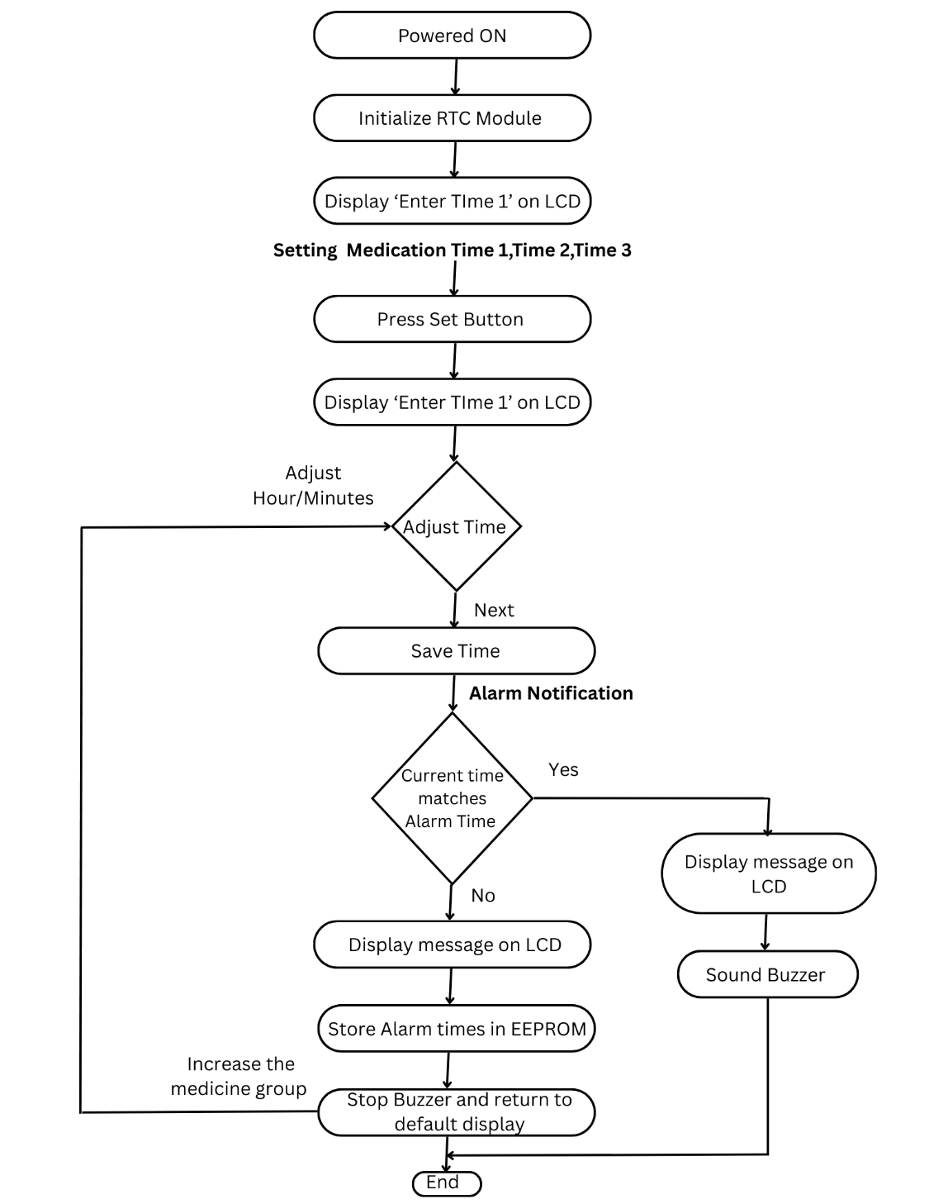

**Figure 3.8: Flow Chart of Smart Medicine Remainder**

# CHAPTER 4

## **RESULTS AND DISCUSSION**

The Smart Medicine Scheduler was successfully designed, developed, and tested using an Arduino Nano microcontroller in conjunction with a 16x2 LCD display, a DS3231 Real-Time Clock (RTC) module, a buzzer, and three LEDs, each representing a distinct pill compartment. The system functioned precisely as intended, showcasing its capability to monitor time accurately and deliver scheduled medication alerts in a timely manner.

Upon initialization, the system's LCD displayed the current date and time, along with the next upcoming medication schedule. The integration of the DS3231 RTC ensured high-precision timekeeping, even in the event of power failures, due to its onboard battery backup. This feature significantly enhances the system's reliability by eliminating the need for reconfiguration after each reboot or power loss.

During testing, three separate medication times were programmed into the system to simulate a typical day’s schedule. The system responded flawlessly: as each scheduled time was reached, the corresponding LED was activated, providing a visual cue for the user. Simultaneously, the buzzer emitted an audible alert, effectively drawing attention to the need to take medication. These dual-alert mechanisms cater to both visual and auditory preferences, increasing accessibility for users of different ages and capabilities.

The buzzer's tone was intentionally kept within a moderate volume range—sufficiently loud to be noticed in a household environment without causing undue disturbance. Users could acknowledge the alert by pressing a dedicated push button. Once pressed, the system automatically reset the alert status, turned off the corresponding LED and buzzer, and resumed its operation, awaiting the next scheduled reminder.

One of the most notable observations during testing was the exceptional stability of the DS3231 RTC module. Over a continuous 24-hour period, no measurable time drift was detected, underscoring the component's accuracy and making it highly suitable for long-term applications where precise scheduling is critical. Moreover, the 16x2 LCD display performed reliably under varying ambient lighting conditions, with characters remaining legible throughout.

The Arduino Nano, despite its limited memory and I/O capacity, managed the system’s tasks efficiently. It was capable of executing real-time operations, handling input/output coordination, and maintaining data flow to the display—all without noticeable delays or system lag. This validates the Nano’s adequacy for compact and low-cost embedded healthcare solutions.

However, one limitation identified during the prototype phase was the restriction to only three medication slots, primarily dictated by the number of LEDs used. For individuals on more complex medication regimens requiring more frequent doses, this configuration may not be sufficient. To address this, future iterations could explore the integration of addressable RGB LED strips (such as WS2812), enabling scalable alert indicators within the same hardware footprint.

Further, the addition of remote notification features—such as a Bluetooth or GSM module—could significantly expand the system’s usability by allowing caregivers or family members to receive alerts on their mobile devices. A companion mobile application could provide a user interface for setting or adjusting medication schedules remotely, improving overall user interaction and flexibility.

In conclusion, the Smart Medicine Scheduler demonstrates strong potential as a practical, low-cost assistive technology. It effectively addresses the common issue of missed medication doses, especially for elderly individuals or patients managing multiple prescriptions. Its simplicity, reliability, and expandability position it as a viable solution for both personal home use and small clinical setups, with future enhancements promising even broader applicability.

**Table 4.1: LED color reading for the medicine group**

|  |  |
| --- | --- |
| **LED** | **GROUP** |
| GREEN | GROUP 1 |
| YELLOW | GROUP 2 |
| RED | GROUP 3 |

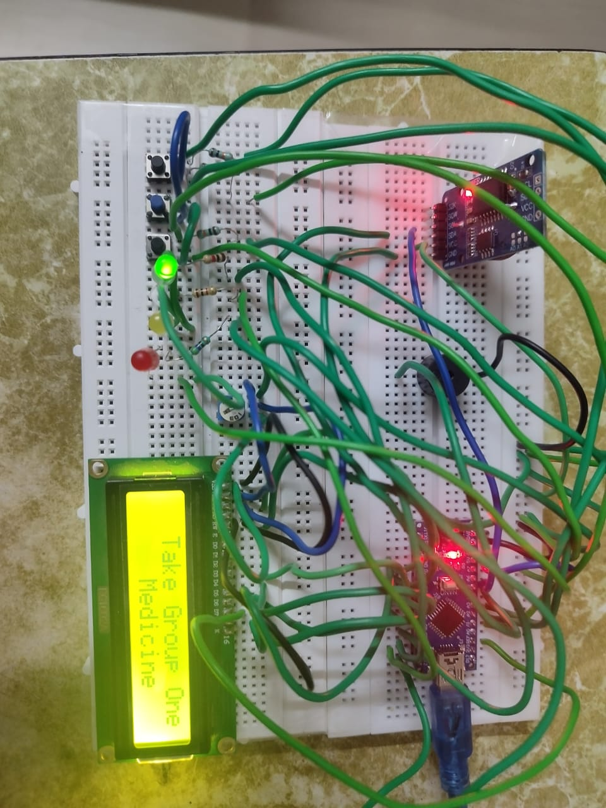

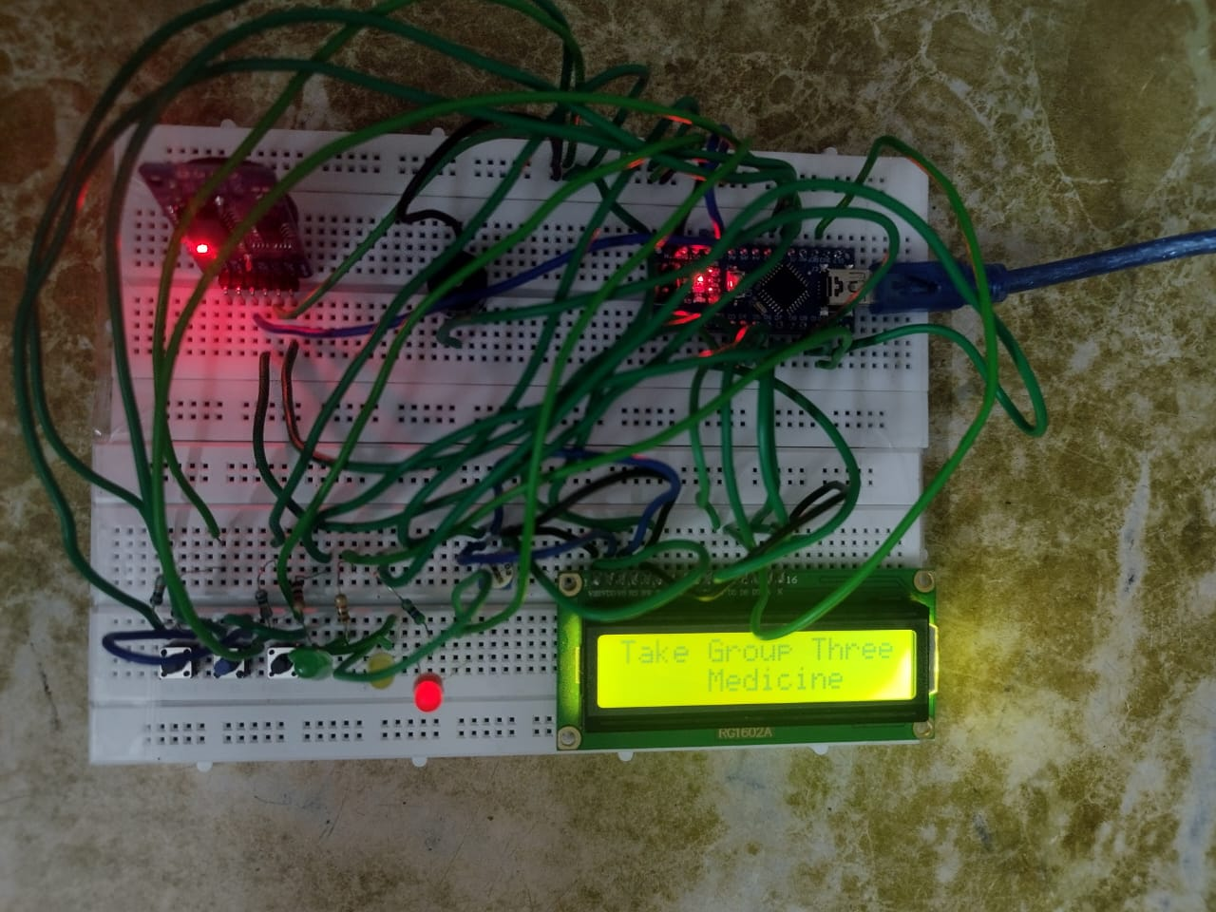

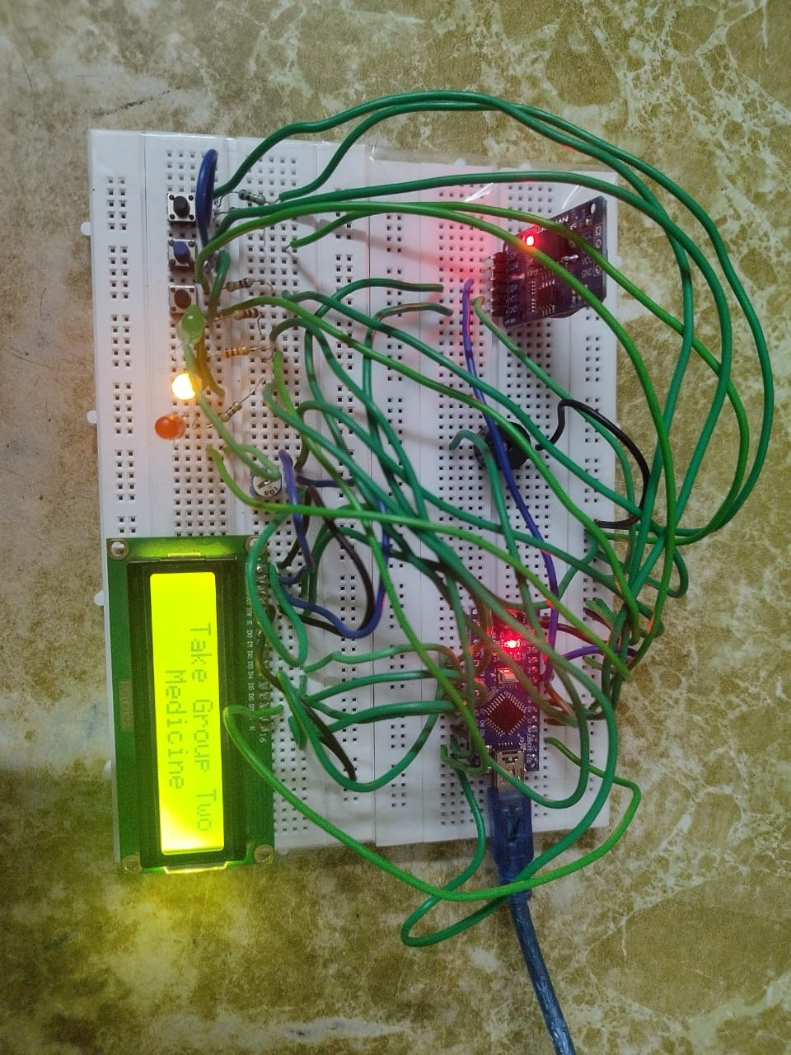

**Figure 4.1: Working Hardware Model**

# CHAPTER 5

## **CONCLUSION**

The Smart Medicine Scheduler was successfully developed using Arduino Nano, an RTC module, an LCD display, a buzzer, and LEDs. The system accurately tracks real-time and provides timely alerts, ensuring users adhere to their medication schedules. By integrating EEPROM memory, it guarantees the retention of user-set alarms even during power interruptions, enhancing system reliability. The combination of buzzer alerts, LED indicators, and clear LCD instructions ensures high user engagement and ease of use.

This project effectively demonstrates how affordable electronic components can be harnessed to address real-world healthcare needs, particularly benefiting elderly individuals and those with busy lifestyles. Future enhancements could include increasing the number of reminder slots and integrating mobile notifications for added convenience. Overall, the Smart Medicine Scheduler achieves its goal of delivering a simple, cost-effective, and dependable medicine reminder solution.

# REFERENCES

1. Diaa Salama Abdul Minaam, Mohamed Abd-ELfattah, Smart drugs: Improving healthcare using Smart Pill Box for Medicine Reminder and Monitoring,” Future Computing and Informatics Journal (published by Elsevier), vol. 3, pp 443-456, November 2018.
2. S. Pavithra, V. Boomika, S. Jeyasree Bala, G. Prisha, " Automatic Pill Dispenser," International Journal of Research in Engineering, Science and Management, vol. 7, no. 1, January 2024.
3. Payal Gawande, Ritika Chitarlewar, Ritik Tirpude, Saurav Kaikade, Rohit Sonare, " Medicine Scheduler Using IoT," International Research Journal of Modernization in Engineering Technology and Science, vol. 6, no. 4, 2024.
4. P. Dayananda, Amrutha G. Upadhya,” Development of Smart Pill Expert System Based on IoT,” Journal of the Institution of Engineers (India) Series B, vol. 105, no. 3, pp 457–467, 2024.
5. T. Vaishnavi, B. Parthasarathy, " Medicine Reminder and Monitoring System Using IoT," International Journal of Novel Research and Development (IJNRD), vol. 8, no. 5, 2023.
6. Zara Nasir, Amina Asif, Muhammad Nawaz, Muhammad Ali, " Design of a Smart Medical Box for Automatic Pill Dispensing and Health Monitoring," Proceedings of the 2nd International Conference on Emerging Trends in Electronic and Telecommunication Engineering, 2023.
7. Girish Mantha, Sathyanarayana K B, H K Pradeep, " Smart Medicine Reminder," International Journal of Advanced Research in Computer and Communication Engineering (IJARCCE), vol. 11, no. 1, 2022.
8. Swetha K B, Morium Sultana Majumdar, " Survey on Smart and Safe Medication Box for Medication System with Timely Reminders," IRE Journals, vol. 6, no. 1, 2022.
9. Dharsh Nivedhan, S Saranya, T Shruthi Sangamithraa, Er. T. Jenish, " Smart Medicine Dispenser (SMD)," International Journal of Research Publication and Reviews, vol. 3, no. 5, pp. 1220-1224, 2022.